**AI Lab – 5**

**BFS and A\***

**DIVYANSH SINHA**

**RA1811030010045**

**BFS (Best First Search)**

from queue import PriorityQueue

v = 14

graph = [[] for i in range(v)]

def best_first_search(source, target, n):

visited = [0] * n

visited[0] = True

pq = PriorityQueue()

pq.put((0, source))

while pq.empty() == False:

u = pq.get()[1]

print(u, end=" ")

if u == target:

break

for v, c in graph[u]:

if (visited[v] == False):

visited[v] = True

pq.put((c, v))

print()

def addedge(x, y, cost):

graph[x].append((y, cost))

graph[y].append((x, cost))

addedge(0, 1, 6)

addedge(0, 2, 5)

addedge(1, 3, 9)

addedge(2, 4, 1)

addedge(2, 5, 8)

addedge(3, 6, 3)

addedge(4, 7, 5)

source = 0

target = 7

best_first_search(source, target, v)

**Output:**

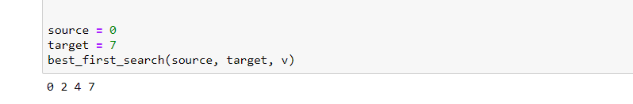

**Explanation:**

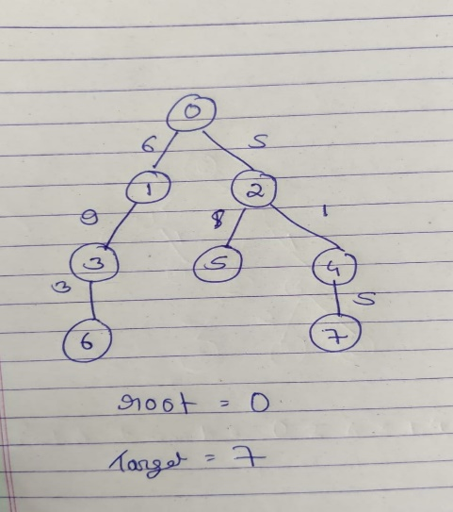

In this graph, we have applied the BFS, and the root node is 0, whereas the target node is 7, so the path which is more efficient that which cost less weight is 0, 2, 4, 7.

**A\***

def aStarAlgo(start_node, stop_node):

open_set = set(start_node)

closed_set = set()

g = {} #store distance from starting node

parents = {}# parents contains an adjacency map of all nodes

#ditance of starting node from itself is zero

g[start_node] = 0

#start_node is root node i.e it has no parent nodes

#so start_node is set to its own parent node

parents[start_node] = start_node

while len(open_set) > 0:

n = None

#node with lowest f() is found

for v in open_set:

if n == None or g[v] + heuristic(v) < g[n] + heuristic(n):

n = v

if n == stop_node or Graph_nodes[n] == None:

pass

else:

for (m, weight) in get_neighbors(n):

#nodes 'm' not in first and last set are added to first

#n is set its parent

if m not in open_set and m not in closed_set:

open_set.add(m)

parents[m] = n

g[m] = g[n] + weight

#for each node m,compare its distance from start i.e g(m) to the

#from start through n node

else:

if g[m] > g[n] + weight:

#update g(m)

g[m] = g[n] + weight

#change parent of m to n

parents[m] = n

#if m in closed set,remove and add to open

if m in closed_set:

closed_set.remove(m)

open_set.add(m)

if n == None:

print('Path does not exist!')

return None

# if the current node is the stop_node

# then we begin reconstructin the path from it to the start_node

if n == stop_node:

path = []

while parents[n] != n:

path.append(n)

n = parents[n]

path.append(start_node)

path.reverse()

print('Path found: {}'.format(path))

return path

# remove n from the open_list, and add it to closed_list

# because all of his neighbors were inspected

open_set.remove(n)

closed_set.add(n)

print('Path does not exist!')

return None

#define fuction to return neighbor and its distance

#from the passed node

def get_neighbors(v):

if v in Graph_nodes:

return Graph_nodes[v]

else:

return None

#for simplicity we ll consider heuristic distances given

#and this function returns heuristic distance for all nodes

def heuristic(n):

H_dist = {

'A': 11,

'B': 6,

'C': 99,

'D': 1,

'E': 7,

'G': 0,

}

return H_dist[n]

#Describe your graph here

Graph_nodes = {

'A': [('B', 2), ('E', 3)],

'B': [('C', 1),('G', 9)],

'C': None,

'E': [('D', 6)],

'D': [('G', 1)],

}

aStarAlgo('A', 'G')

**Output:**

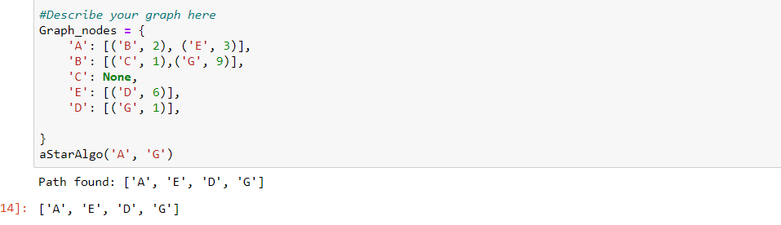

**Explanation:**

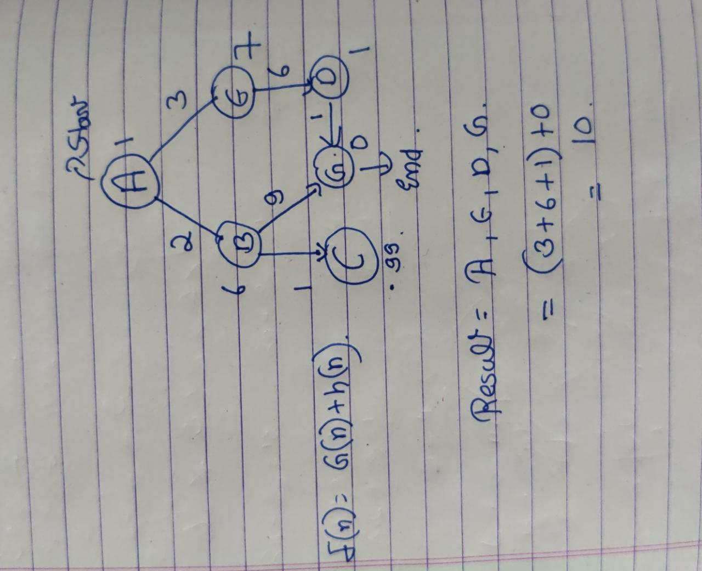

In this graph, we have used the function F(n) = G(n) + h(n), where h(n) is the heuristic function and G(n) is holding the actual cost, thus from this graph the shortest path with least weight is A, E, D, G.

**Result:** Thus, both the algorithm code was written and executed successfully.